The Voice Waterford Newsletter

Table of Contest
- Preamble
- pastor’s corner
- strategic plan
- district demographic data
- kids corner
- Success stories
- Stewardship Corner
- SOP Corner
- disciplinary procedures
- secrets of success in the Christian experience

PREAMBLE:
The Birth of this newsletter entitled “The Voice” was inspired by the desire to share with the Church information on what is taking place in the mission field, and to discuss theological issues that may be of concern and are relevant to our context. Knowledge is power so goes the old adage, and as the information is shared, members are able to discover the shortcomings and successes of the district. When theological issues are discussed, spiritual growth is enhanced.
The greatest enemy of success are the past successes “You must learn from your past mistakes; but not lean on your past successes.” As we examine the past successes; we encourage each other not to be complacent; but to be forever aiming high and thriving for excellence. Our successes should not make us complacent but they should propel us to greater heights.
Challenges are the stepping stones. When we look at our shortcomings; we are made to realise what it is that makes one fail and build from there. Albert Einstein once said “I have failed 99 times and have failed, but on the 100th time came success.” An accident is a total loss unless something meaningful has been learnt from it. When we look at our shortcomings we should not despair, we can only despair/fear only “as we forget how the Lord has lead us in the past.”
The title “The Voice” was motivated by the words of John the Baptist, “ a voice of one calling in the desert, prepare the way of the Lord, make straight paths for him”(NIV Mark 1:3). We strongly believe we are the John of today “who are to call out for people to prepare the way of the Lord. John was a herald of the first advent of Christ and we believe that we have been called to herald the second coming of our Lord and Saviour Jesus Christ.
The title “The Voice” continually reminds us that we are to noise it abroad that Jesus saves. As Waterford District we are overwhelmed by the desire to share the good news of salvation and we have purposed to be that voice; the voice that warns the world of the coming judgements of God; and the voice that prepares a people for Jesus’ Second Advent.
Letters:
If one of our newsletters has landed in your hands; we kindly ask you to give us feedback that can help us improve these articles. Where there are many advisors there is bound to be success “for lack of guidance a nation fails, but many advisors make victory sure” (NIV) Proverbs 11:14). Help us to grow by giving your input; we greatly value the input of our readers. You can send your messages through E-mail at nagidos.ngwenya07@gmail.com or text a message to Cell number 0713 133 851 or submit your letter to your communications secretary/Elder/Pastor.

Pastor’s conner (Pastor Obadiah M Ngwenya)
“And this is life eternal, that they might
know thee the only true God, and Jesus
Christ, whom thou hast sent” (KJV John
17:3).
“Saving knowledge is here defined as
that which is centered upon the true
God..., and upon Jesus Christ. Men will
be rejected in the last day because they
rejected the essential knowledge.
The GOD we worship is God who can
be known. He is “Deus revelatus” God who reveals himself to his created beings. He reveals himself to us in two ways, the general and special revelation.
General revelation is God’s self- manifestation through (a) Divine providence Acts 17:23-28, (b) nature Psalm 19:1-6, Romans 1:18-20, (c) course of history (d) human relationships/interactions, (e)
inner being (intuition). General revelation is universal, everybody has access to
it, sinners and those converted alike are exposed to this form of revelation.

Special revelation is when God reveals himself to particular people at definite
times and places and this enables them to have a saving relation with him. There
are different modes in special revelation and they include (a) Personal encounters,
(b) theophanys (dreams / visions /audible voice Hebrews 1: 1, 3), (c) Incarnation
(John 1:14), and (d). Scriptures (the Bible). God wants to reveal Himself to us this Quarter in a special way through His word.

As we devote ourselves to the study of the word, we avail ourselves to the special revelation of God. Scriptures reveal most of the things we need to know about God in order that we may be
saved. As you take time to read the bible, be careful not to take it as a book of information.
It is a book that introduces us to a person, the person of Jesus Christ. As you read through the pages of the Bible (A Chapter per day), have an encounter with Jesus and be led into a personal, saving
relationship with Him.

Purpose to know Jesus, the Seed of the woman. Gen 3:15, a star out of Jacob
Numb 24:17, the mighty God Isa 9:6, the Everlasting Father Isa 9:6, the Prince of peace Isa 9:6, the Lord our righteousness’Jer 23:6, the Son of God Dan 3:25, the Son of Man Dan 7:13, the Branch Zech 6:12, the Son of Righteousness Mat 4:2, the Word Jn 1:1, the Lamb the Light of the World John 8:12, the Door of the sheep Jn 10:7, the Resurrection and the Life 11:25, the Way the Truth and the Life Jn 14 :6, the True Vine Jn 15:1, the Rock 1 Cor 10:4, the second Adam 1Cor 15:45,47, the Chief Cornerstone Eph 2:20, the High Priest Hebrews 4:14, the Chief shepherd 1Peter 5:4, the
Advocate 1Jn 2:1, the King of Kings Rev 19:16, the Lord of Lords Rev 19:16, and the Morning Star Rev 22:16 Know Jesus through the study of the word.

Be blessed.

WATERFORD DISTRICT STRATEGIC PLAN
Mission statement: The Mission of Waterford District is to proclaim the good news of salvation within its territory and beyond; inviting all to become disciples of Jesus Christ and preparing them for his imminent return as expressed in Revelation 14:6-12.

Vision: A cultured, Christ- centred, spirit-led district

Values:
Quality
Faithfulness
Transparency
Integrity
Teamwork
Accountability
Biblical-spirituality

District Demographic Data
- POPULATION : 32360
- Church membership at the beginning of the year: 3201
- Actual Membership:
- Church membership at the end of first Quarter: 3275
- NO OF PLOTS/households: 3804
- NO OF SCHOOLS: 14
- NO OF CLINICS: 1
- NO OF DENOMINATIONS: 73
- COUNCILLOR: 8
- VILLAGE HEADS:34
- kraal head 2
- chief 1
- COMPANIES: 14
- SHOPPING CENTRES: 24
- GRINDING MILLS: 11
MEMBERSHIP
ORGANISED CHURCHES
NAME OF CHURCH | OFFICIAL MEMBERSHIP | ACTUAL MEMBERSHIP
Waterford | 1067
Kensington | 561
Nhlozamandla | 757
Sihlengeni | 263
Gumtree | 341
Somerwest | 270

companies
NAME OF COMPANY | OFFICIAL MEMBERSHIP | ACTUAL MEMBERSHIP
Hope fountain | 109
Stimulation | 114
Manningdale | 62
Howmine | 144
Valleyview | 23
Springfarm | 89
Warringham | 65
Ntabamhlophe | 61
Claremont | 35
Emaqaqeni | 35
Wasmer | 21
Makwibila | 34

NEEDS:
Pr. & Sec. Schools; Stationary & fees; food; clothing; water;clinic; lack of IDs; care for orphans,elderly & disabled; illiteracy; health & fitness centre, shelter; road, electricity, toilets, church structure, borehole

Goals & Objectives:
Goal 1 To have baptised 810 souls by 2020 (270 souls annually and nurtured all of them
Action plans/steps:
- Each Church to conduct 4 Evangelistic campaigns annually
- Each Church to conduct 2 revival meetings annually
- to Actively participate in SID & ZWUC led campaigns
- District to 2Trainings for Evangelists in doctrinal preaching
- District to conduct 2 Trainings in self-help skills annually as entering wedges (candle-making; carving; gardening etc.
- Each church to conduct 12 promotions to help Continue OMOS
- District to conduct 2 Health Expo annually
- District to conduct 2 Civic leaders seminars annually
- Each church to conduct 2 Weeks of spiritual emphasis annually
- To revive AMO and conduct 1 camp for man annually
- District to conduct 1 DOCAMO rally annually
- Each church to conduct 4 women’s breakfast programs annually
- To participate in all Federation AY Pathfinder & Adventurer programs
- Each church to establish a Bible & SOP reading club.
- District to conduct 1 Bible and Spirit of prophecy Symposium annually
- Each church to establish an SOP library
- To ensure that 70% of membership attends camp meetings in annually
- Each church to conduct 2 VBS program annually.

Goal 2: TO HAVE PROMOTED A WHOLISTIC APPROACH TO STEWARDSHIP (6Ts) AND RAISED MEMBERSHIP FAITHFULNESS TO 80% IN TITHES AND OFFERINGS
Action plans:
- District to remit $84000,00 by end of 2018
- District to remit $7000,00 in Tithes on a monthly bases
- District to remit $42000 by end of 2018 in offerings
- District to remit $3500,00 on a monthly bases in offerings
- Each church to conduct 2 Stewardship seminars annually
- Each church to conduct stewardship lessons in Fishers of men classes

Goal 3: TO HAVE TRAINED ALL LOCAL CHURCH OFFICERS IN THE ADVENTIST UNDERSTANDING OF LEADERSHIP
Action Plans
- TO CONDUCT 1 DISTRICT LAUNCH annually
- TO TRAIN ALL CHURCH OFFICERS
- Each church to conduct 4 leadership seminars/lessons annually
- Each church conduct 2 seminars on minute writing annually
- Each church conduct 2 seminars/lessons on how to chair meetings
- Each church to conduct church board meeting at-least once a month and church business meeting at-least once a quarter.Goal 4

Goal 4: TO PROMOTE INFRASTRUCTURAL DEVELOPMENT WITHIN OUR TERRITORY
Action Plans:
- To complete all Church structures under construction
- To construct a toilet in each of our church stands being developed
- to Construct at-least one school
- to Construct at-least one clinic
- to establish a schools development committee
- to establish infrastructural development committee

Goal 5: TO ENSURE THAT ALL OUR PROGRAMS ARE NEEDS ORIENTED
- To establish at-least 3 exercise clubs/associations/teams
- District to conduct at-least 2 Health Expos annually
- District to conduct at-least 2 stop smoking programs
- District to conduct 1 food and clothing distribution programs annually
- District to drill at-least one borehole for a needy community
- District to translate at-least one SOP book into Ndebele
- to build at-least one clinic & one school

Goal 6: To grow companies into churches
- To organise at-least 3 companies into Church
- To establish at-least 3 sabbath school branches t

Evangelism Strategies
- Enrol people on VOP
- Distribute book of the year
- distribute adventist literature
- recruits more LEs
- conduct family life seminars for both adventist and non adventist couples
- establish exercise clubs or teams
- conduct stop smoking programs
- conduct civic leadership seminars

How to address syncretism and dual allegiance
- educate the church on biblical position
- to hold revival meetings
- to preach targeted sermons
- to intensify prayer-band
- to conduct Civic leadership seminars
- to deploy Bible workers in affected areas KIDS CORNER

Success stories:
PERSONAL MINISTRIES | STEWARDSHIP  the 22/05/2018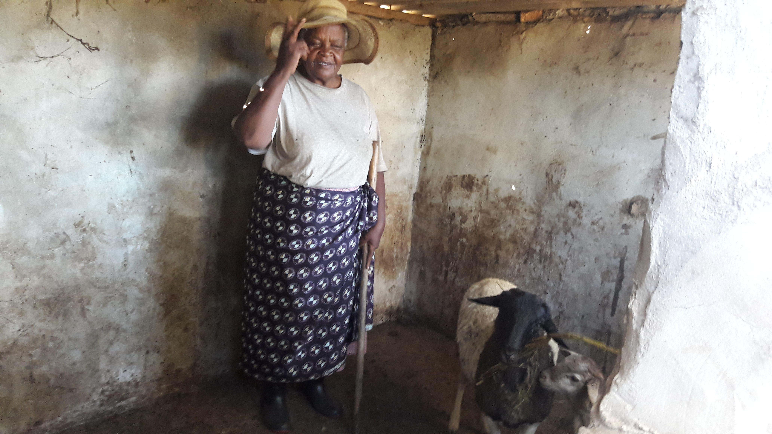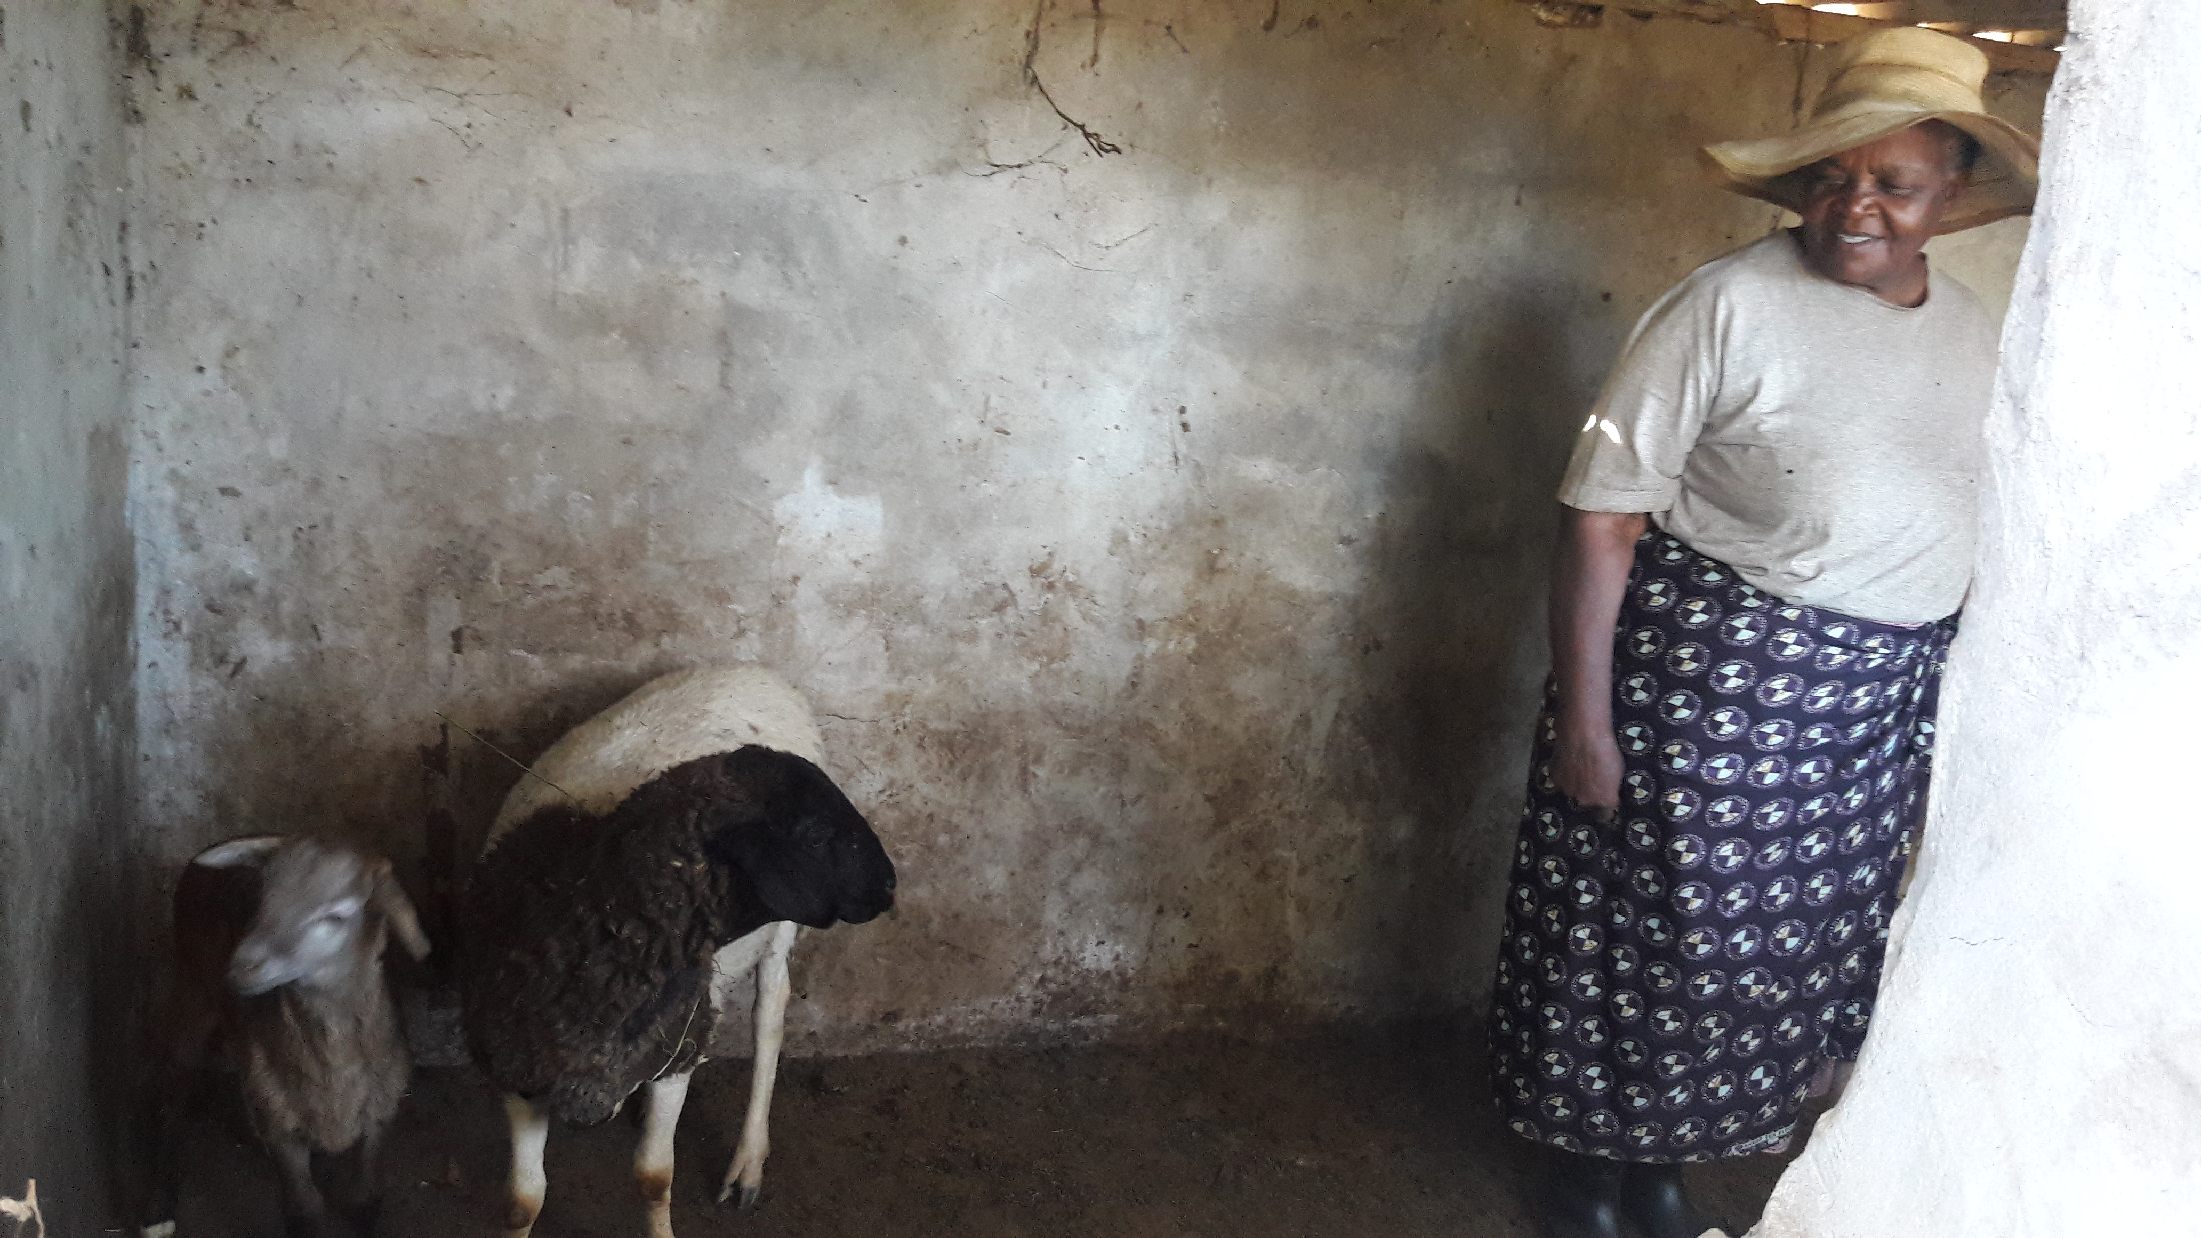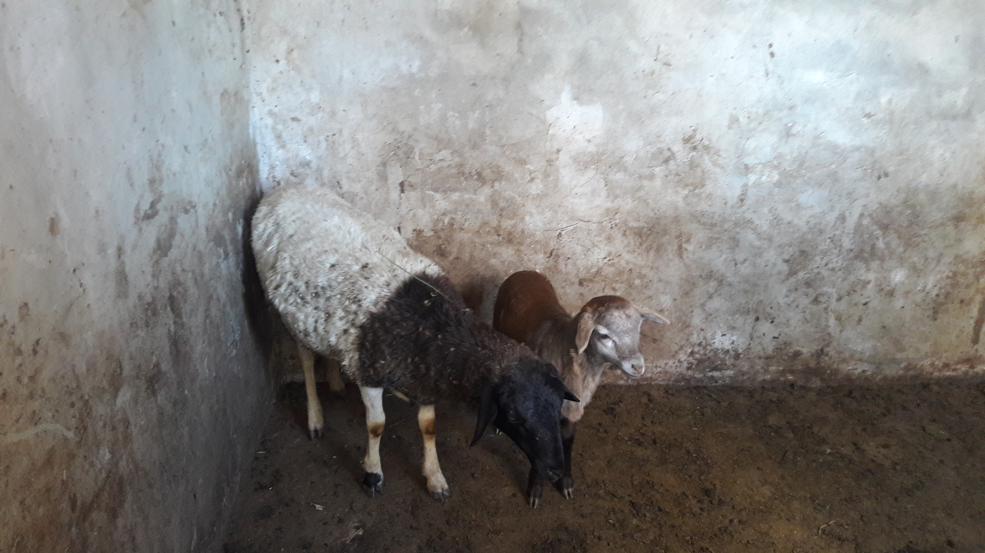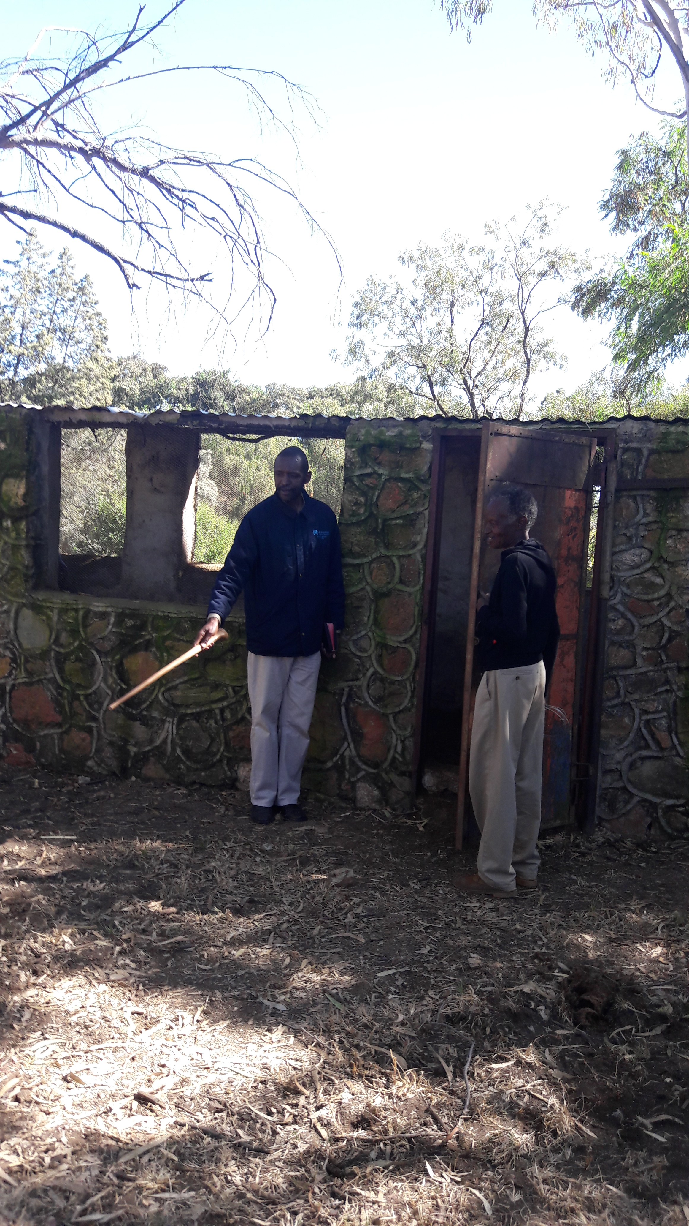 | AY  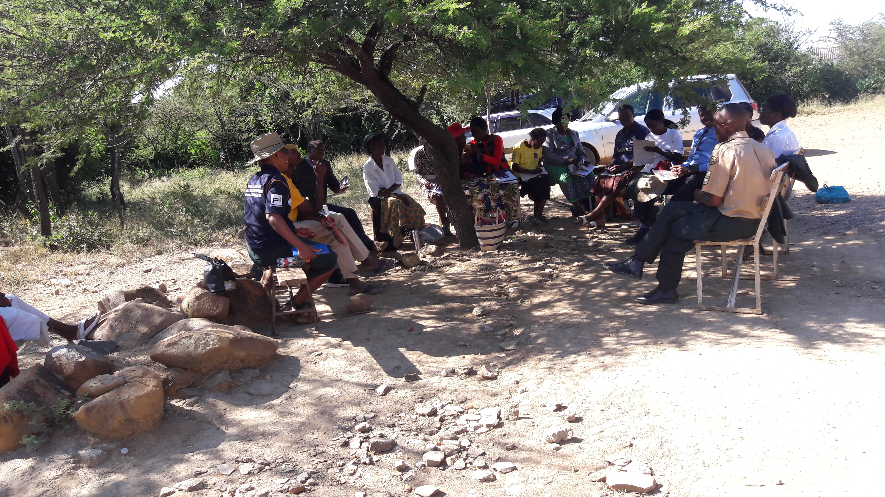  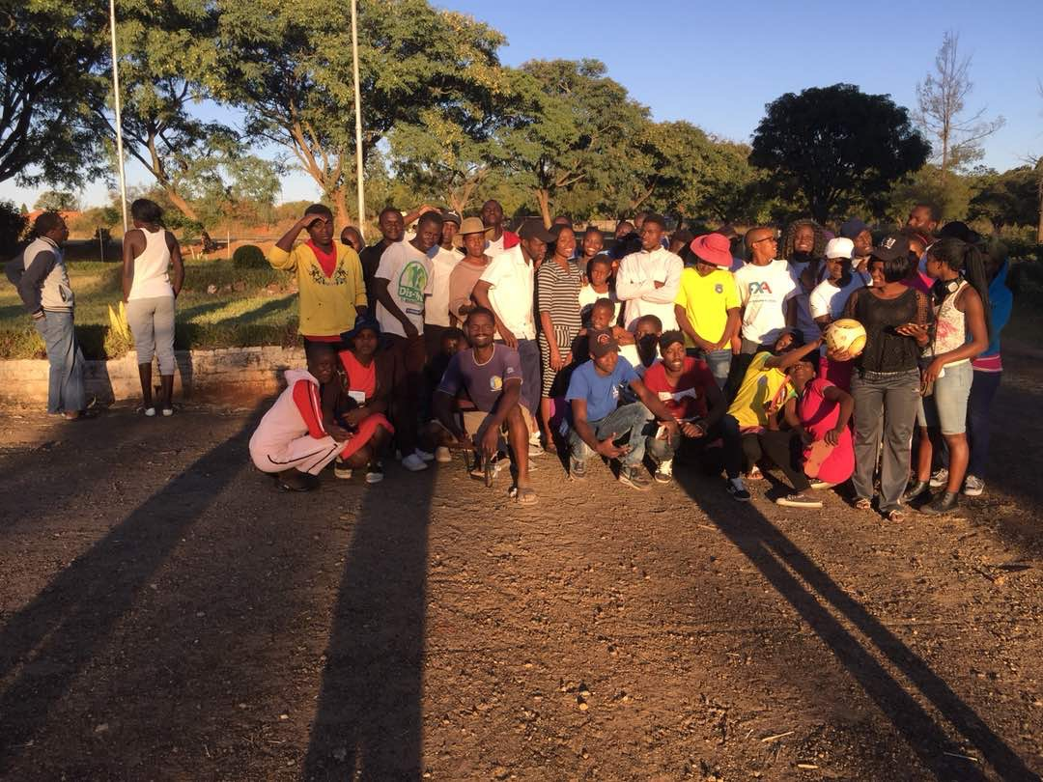  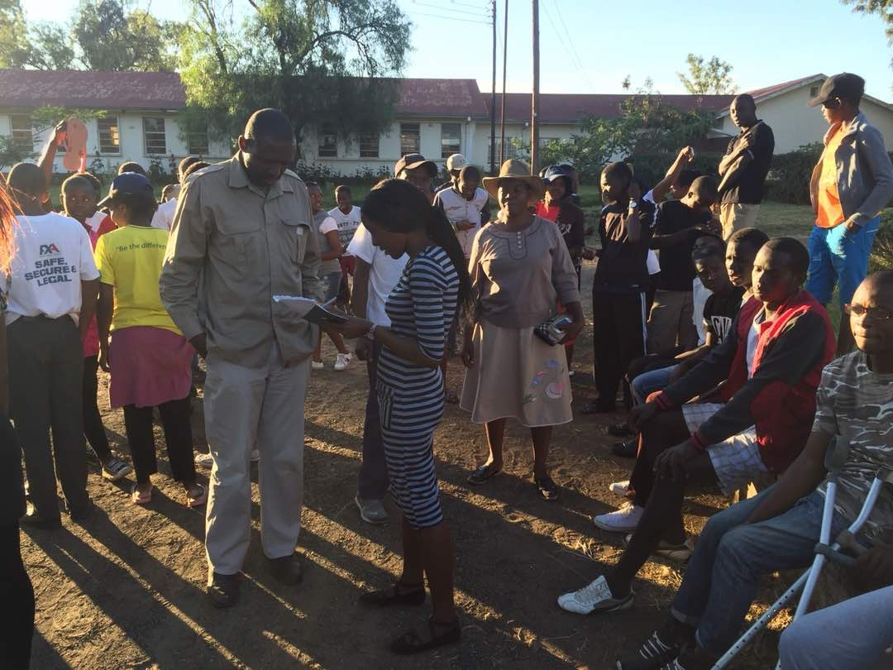   | ZAAM  One ZAAM district seminar was conducted at Kensington Church. We had the blessing of Hosting Mrs Moyo from NAC  
VOP  the  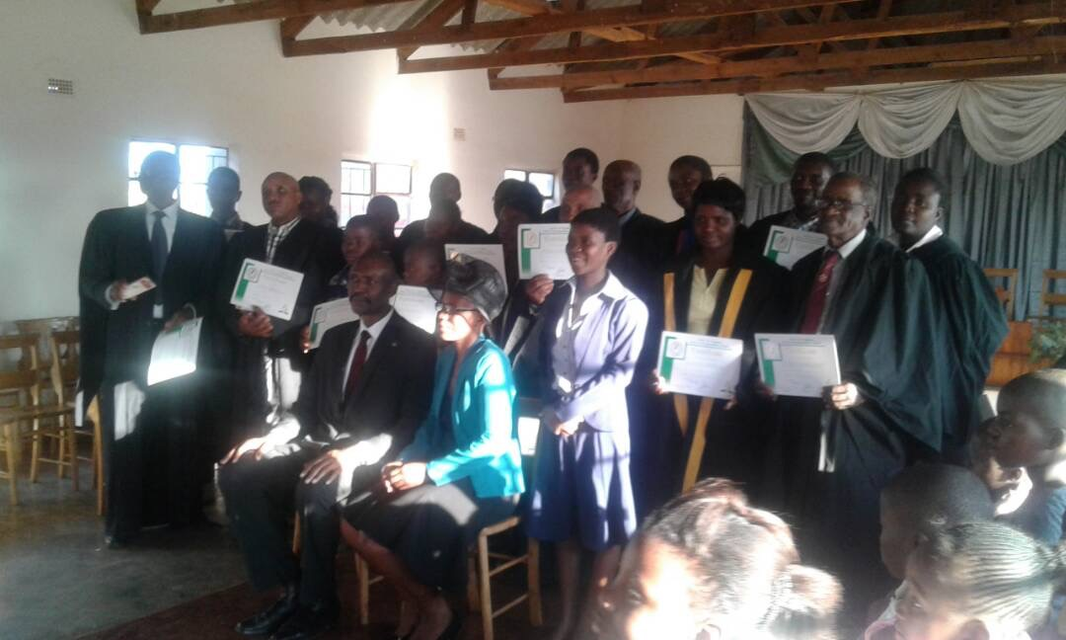the | CHURCH DEVELOPMENT |   communication:
DISTRICT BOARD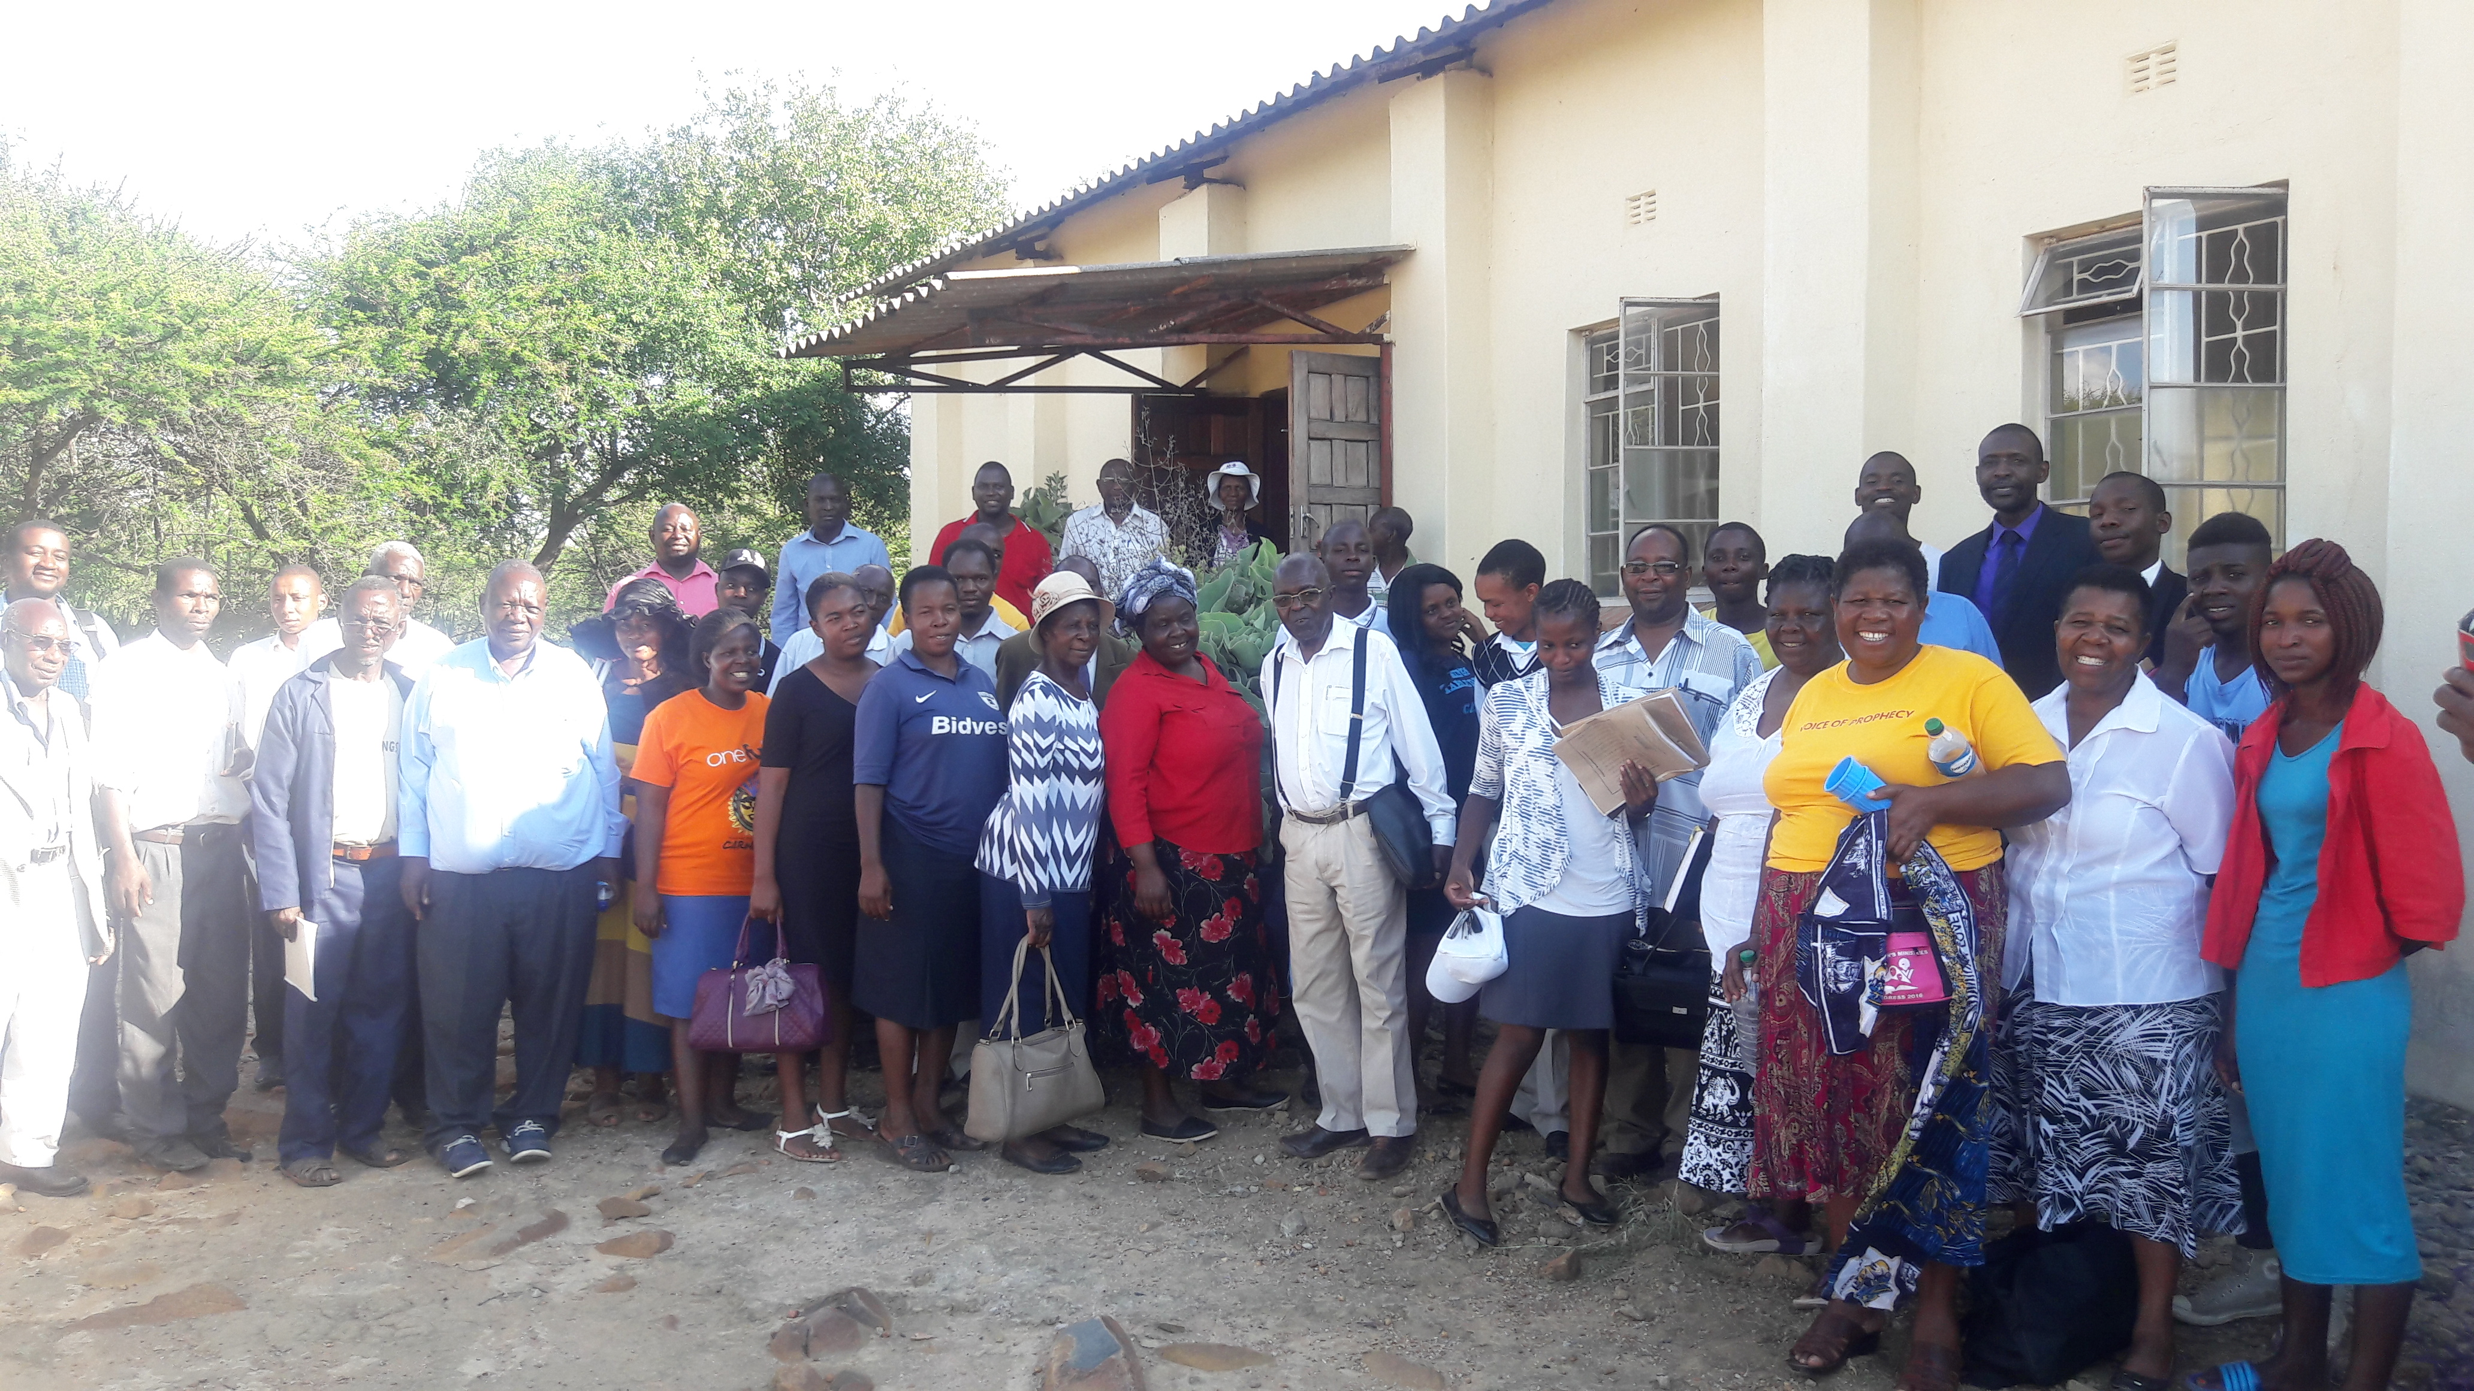  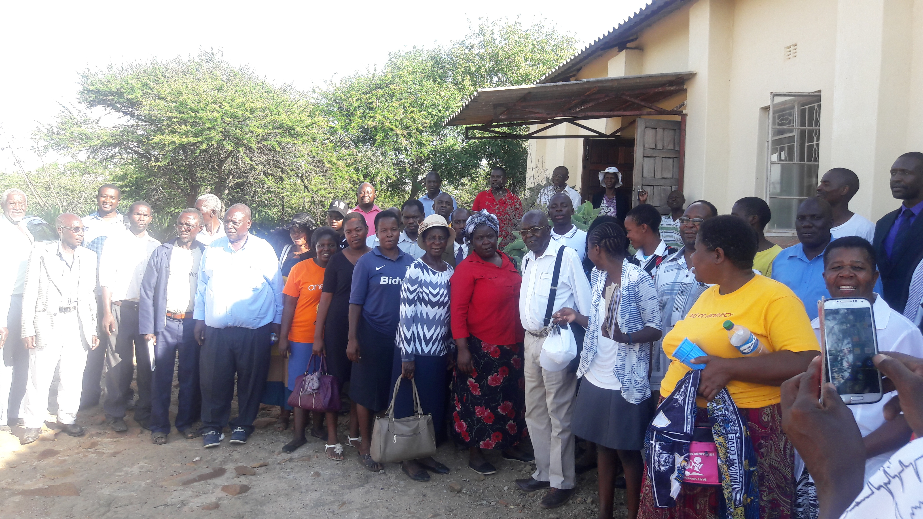 | 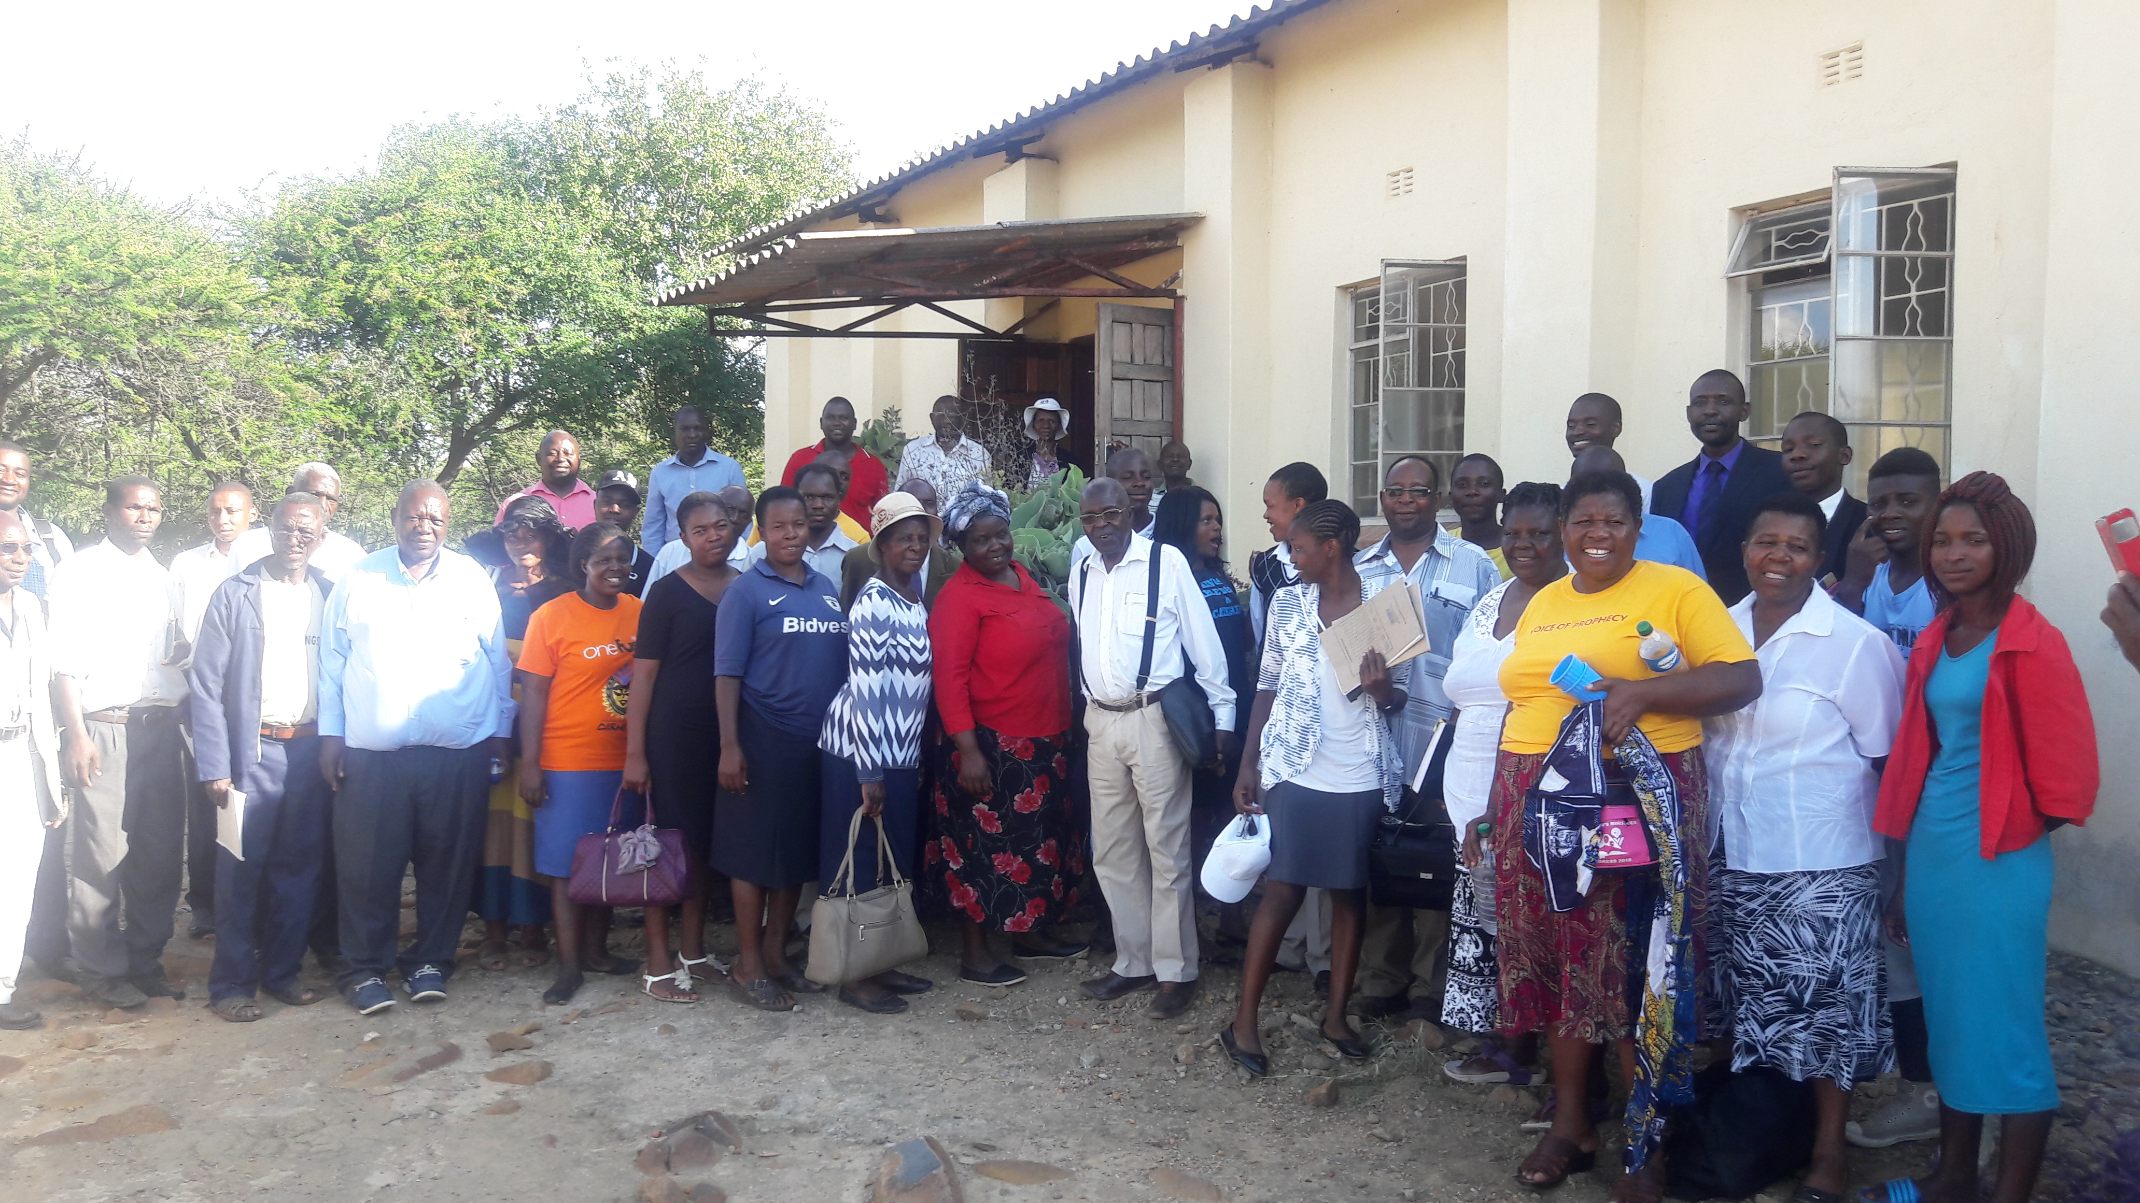 | 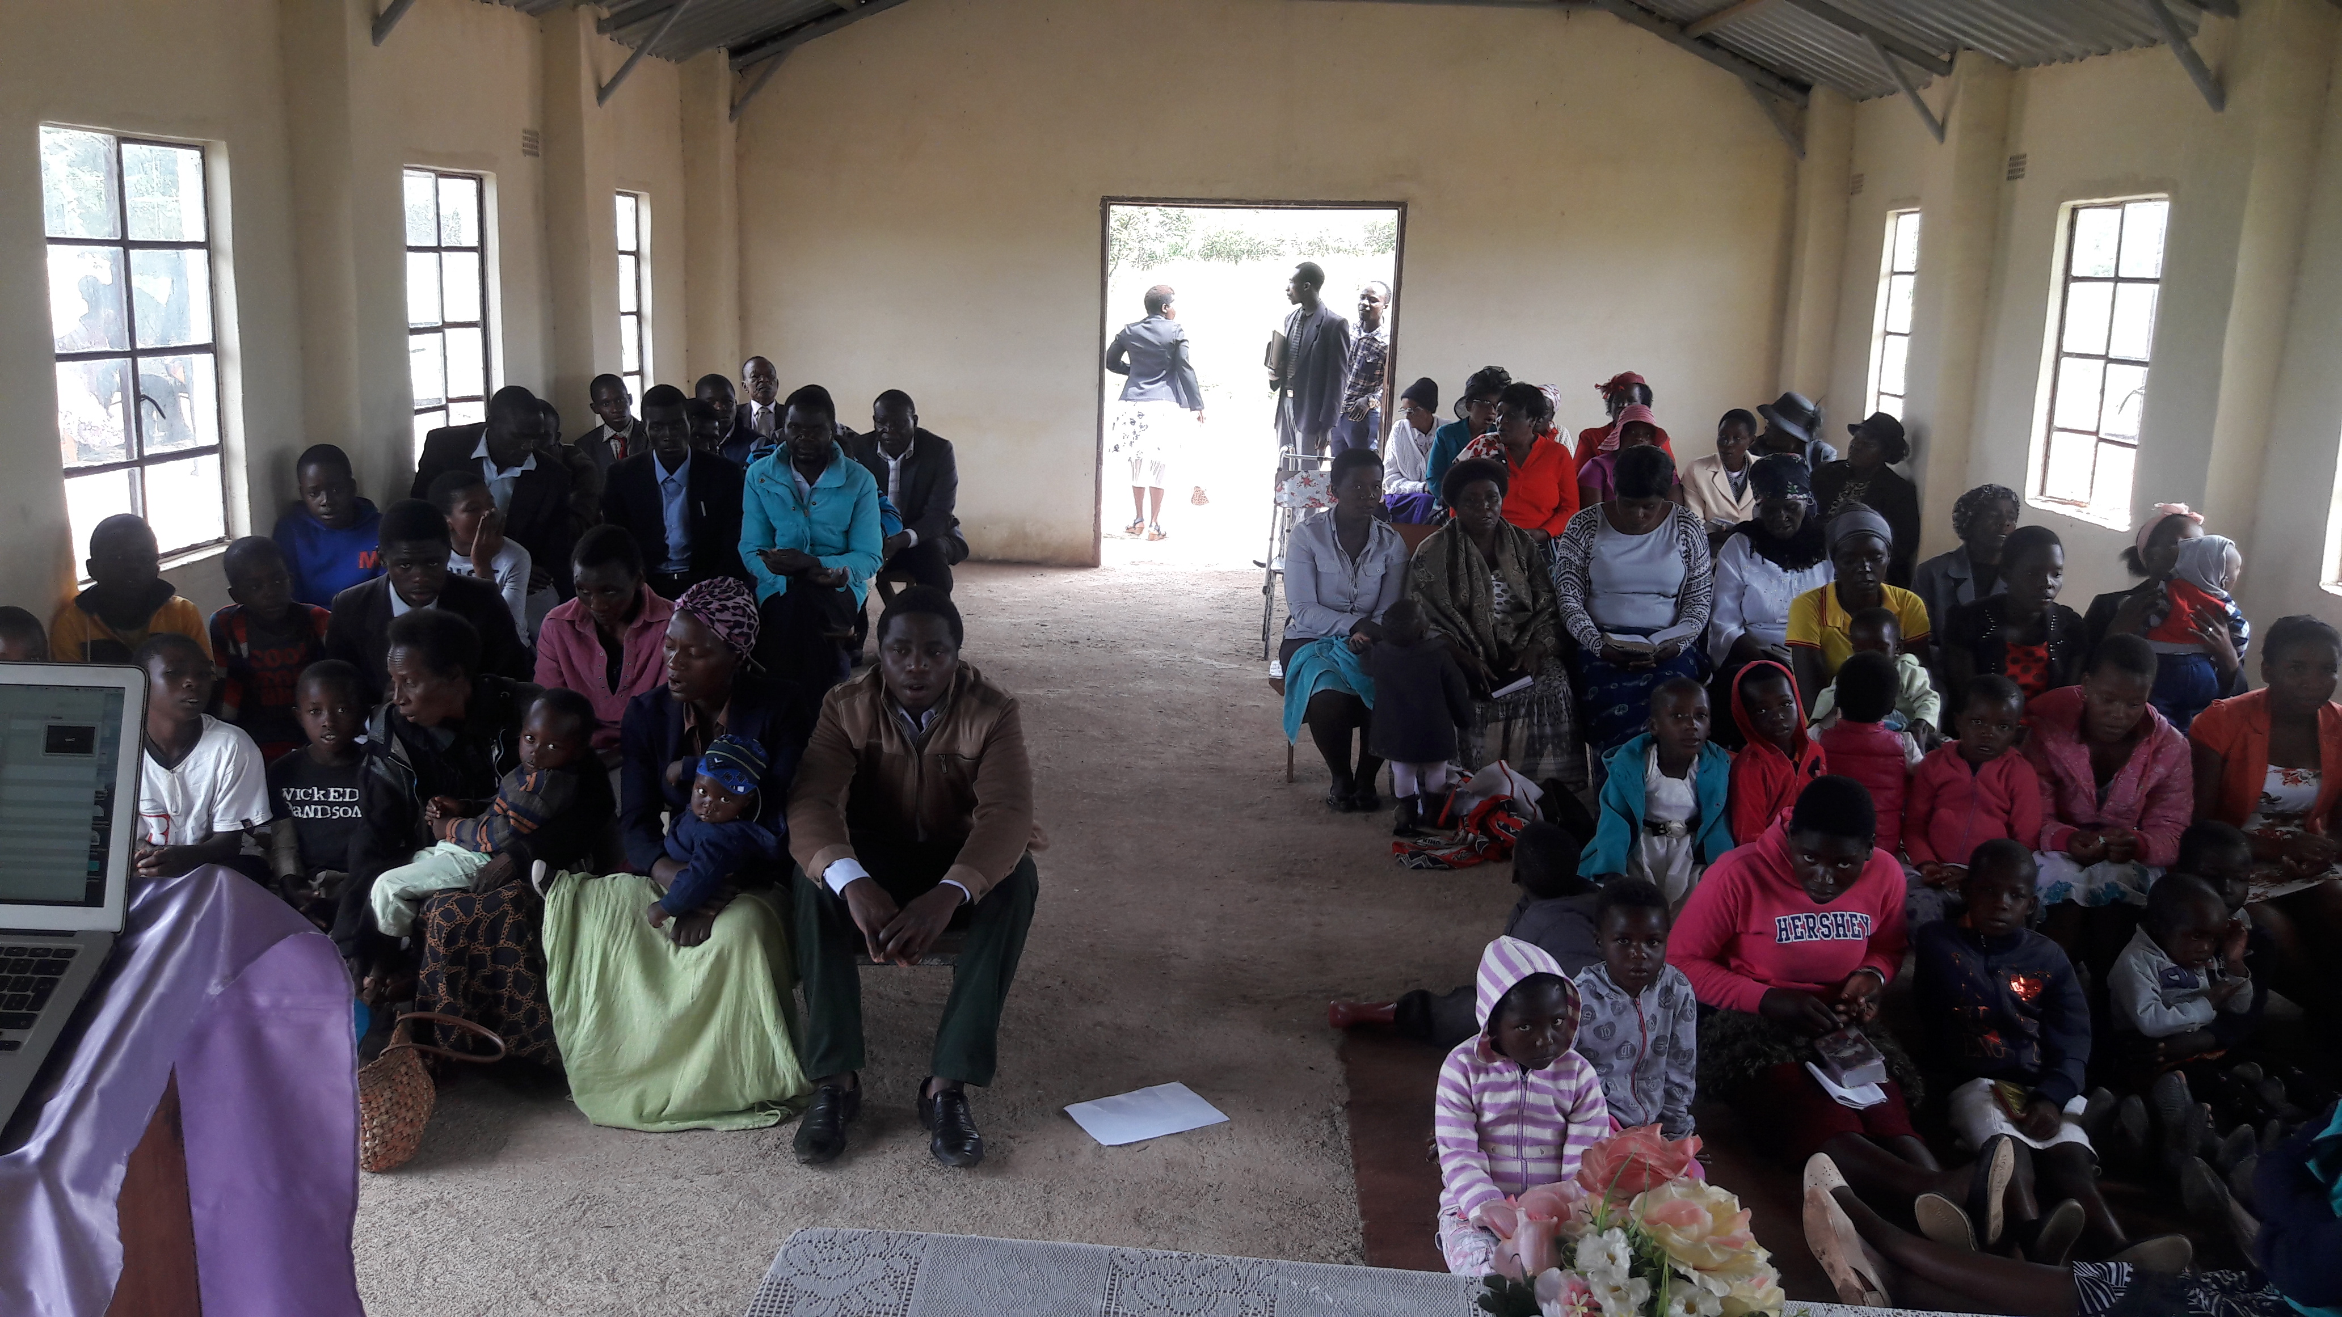

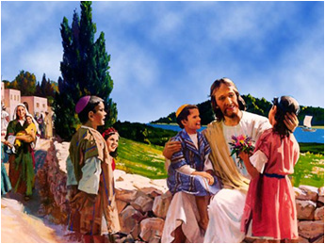
KIDS CORNER
Our story this quarter is about mother Sikhukhukazi with her children (the Chiks). Mother Skhukazi gave her children the law that whenever their lives were threatened they should run and hide under her wings. All her children obeyed except for one called Hendriator. Each time the eagles came to attack, the rest of the chicks would run and hide under their mother’s wings but Hendriator would run and hide under the shrubs.
This continued until Hendriator thought she was more smart that the mother and the other chicks. One day a fire broke out from the nearby bush and fast consumed the vegetation around. As the fire drew closer to where mother skhukhukazi was; she ran and hid on a rock together with the obedient chicks. Hendriator thought she would get away with her stubborn behaviour like at other times; Unfortunately the fire consumed everything including the shrub where Hendriator was and she perished.
Our story teaches us to obey our parents and to put all our trust in God our rock and our shelter. It is dangerous boys and girls to disobey our parents. Obedience preserves our lives and disobedience leads to destruction. Our story also teaches us that we should run to Jesus the rock of ages whenever calamities strike. We are safe only as we hide under his ever-loving arms.
You need to purpose in your heart to obey your parents and to make Jesus your hiding place. “Children obey your parents in the Lord for this is right” (Eph. 6:1).
Story by the Shepherdess.

STEWARDSHIP CORNER

STEWARDSHIP GEMS
When you begin to actively and faithfully return 10% or more of all your income to the Lord’s work, you will be surprised at...
1.The effect faithful giving has in making you a wiser manager over all the rest of the money and possessions you have.
2. The deepening of your spiritual life through trusting the Lord to meet your needs.
3. The increased ease in which you meet your other financial obligations on the 9/10ths of the income you have left.
4. The way that starting to give 10% leads to more generous giving than you ever dreamed possible.
5. The generous amount of money you will be able to give to the Lord’s work.
6. The unexpected provisions that God brings into your life.
7. And the surprise you have when you wish you had started giving 10% or more much sooner.
N.B I absolutely believe in the power of tithing. My own experience is that the more I give away, the more that comes back (by Ken Blanchard, author of the “One Minute Manager”)

QUARTELY REPORT
MEMBERSHIP | Waterford | Kensington | Some west | Nhlozamadla | Gumtree | Sihlengeni | Total
Goals for the Current Year
1 To have 40% of members who are tithing regularly | 35 | 20 | 31 | 25.4 | 32.2 | 10.9 | 26
2 Combined offerings/donations to be equivalent t0 25% of the tithe | 33 | 77 | 34.5 | 15.1 | 12.2 | 17.5 | 32
Tithe Report
Percentage of members tithing during this quarter | 35 | 20 | 31 | 23.1 | 17.7 | 12.7 | 23.2
Percentage of members tithing last quarter | 33 | 23 | 35.8 | 10.1 | 22.8 |  | 24.9
Growth of tithers compared to the same quarter last year | +2 | -3 | -4.8 | +13 | -5.1 |  | 0.4
Tithe per capita this quarter in local currency | $10.36 | $13.64 | $5.32 | $7.39 | $2.50 |  | $7.84
Average tithe per capita for the 4 quarters in local currency | $3.89 | $5.58 | $38.3 | $8.59 | $1.20 |  | $11.51
Offering Report
Total offerings compared to total to total tithe returned for the quarter | 39.7 | 77 | 34.5 | 15.1 | 38 | 6.1 | $35.07
Total offerings compared to total tithe returned last quarter | 40 | 32 | 20.1 | 15.1 | 50 |  | 31.4
Identified members contributing lump sum offerings | 2 | 4 | 20 | 5 | 4 |  | 7
Offering per capita this quarter in local currency | $3.8 | $5.92 | $7.95 | $1.17 | $0.89 |  | $3.95
Average offerings per capita for last four quarters in local currency | $3.7 | $1.74 | $15.48 | $1.3 | $0.99 |  | $4.63

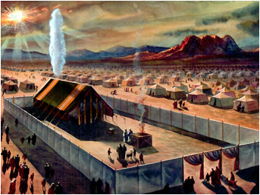
the sanctuary

This is the beginning of a series of Sanctuary lessons. As we press forward towards a revival of primitive godliness, we cannot afford to miss the sanctuary lessons. As you follow through
the lessons have an encounter with Jesus and be led into a personal saving relationship
with him. It gave the Patriarch David great joy to frequent the sanctuary.
In the texts below he states,
1. Psalm 122:1, I was so glad when they said unto me, let us go onto the house of
the Lord.
2. Psalm 84:10 for a day in thy courts is better than a thousand elsewhere. I had rather be a doorkeeper in the house of my God, than to dwell in the tents of
wickedness.
Question; what is it that made David and the sons of Korah so excited about going to the Sanctuary? This and the many other questions about the sanctuary shall be answered as we follow through.

the Importance: the subject of the sanctuary...
should be studied and clearly
understood by the people of God. All
need knowledge for themselves of the
position and work of their great high
priest...” ii
Significance: The sanctuary was a
teacher; or an object lesson that was
meant to help the children of Israel understand
the person of Jesus, his mission
on earth and his ministry in the heavenly
sanctuary today.
Three important lessons from the sanctuary:
1. Sin is costly. No man can redeem the life of another or give to God a ransom for him. The ransom for a life is costly; no payment is ever enough, that he should live on forever and not see decay.
Psalm 49:7-9
2. Sin is deadly:... without the shedding of blood there is no remission of sins
(Heb 9:22)
3. Jesus is the answer: because Jesus lives forever, he has a permanent priesthood. Therefore he is able to save completely those who come to God through him, because he always lives to intercede for them (Heb 7:24-25. N.B The sanctuary basically teaches about Jesus and the plan of salvation. In the sanctuary you find Jesus.
1.the lamb of God that takes away sin, John 1:29
2. Our high priest. Heb 7:24-25
3. Our righteousness
4. The bread of life. John 6:35
5. The light of the world. John 9:5
6. The God who answers prayer
7. The king who reigns with justice and mercy.
8. The king coming in glory. N.B Find Jesus in the Mosaic tabernacle, The Desire of all the ages. That is why David was glad even to be a doorkeeper in the house of the Lord. Be blessed

SPIRIT OF PROPHECY CORNER:

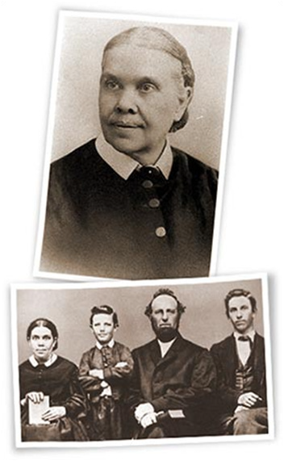
Who Was Ellen White?
Who was Ellen G. White, and why do millions consider
her writings of special value and significance?
In brief, she was a woman of remarkable spiritual gifts
who lived most of her life during the nineteenth century
(1827-1915), yet through her writings she is still
making a revolutionary impact on millions of people
around the world. During her lifetime she wrote more
than 5,000 periodical articles and 40 books; but today,
including compilations from her 50,000 pages of manuscript,
more than 100 titles are available in English. She is the most translated woman writer in the entire
history of literature, and the most translated American author of either gender. Her writings cover a broad range of subjects, including religion, education, social relationships, evangelism, prophecy, publishing, nutrition, and management. Her life-changing masterpiece on successful Christian living, Steps to Christ, has been published in more than 140 languages. Seventh-day Adventists believe that Mrs. White was more than a gifted writer; they believe she was appointed by God as a special messenger to draw the world's attention to the Holy Scriptures and help prepare people for Christ's Second Advent. From the time she was 17 years old until she died 70 years later, God gave her approximately 2,000 visions and dreams. The visions varied in length from less than a minute to
nearly four hours. The knowledge and counsel received through these revelations she wrote out to be shared with others. Thus her special writings are accepted by Seventh-day Adventists as inspired, and their exceptional quality is recognized even by casual readers. As stated in Seventh-day Adventists believe . . . , “The writings of Ellen White are not a substitute for Scripture. They cannot be placed on the same level. The Holy Scriptures stand alone, the unique standard by which her and all other writings must be judged and to which they must be subject” (Seventh-day Adventists
Believe, Ministerial Association, General Conference of Seventh-day Adventists, Washington D.C., 1988, p. 227).).
Yet, as Ellen White herself noted, “The fact that God has revealed His will to men through His Word, has not rendered needless the continued presence and guiding of the Holy Spirit. On the contrary, the Spirit was promised by our Savior to open the Word to His servants, to illuminate and apply its teachings” (The Great Controversy, p. vii). Ellen White was a remarkable woman who, meeting all the tests of a true prophet as set forth in the Holy Scriptures helped found the Seventh-day Adventist church. She lived to see the Advent movement grow from a handful of believers to a world-wide membership of 136,879 that, by 2010, had exceeded 16 million.
Ellen G. White Estate, Silver Spring, Maryland.

DISCIPLINARY PROCEDURE IN THE SEVENTH DAY ADVENTIST CHURCH

The procedure in brief is as follows:
- A matter is reported to the Deacons.
- The Deacons investigate the matter. This includes hearing the Complainant and hearing the person who is subject to be disciplined and his witnesses.

- Once the Deacons have completed their investigations, they must make a recommendation to the Elders Council. The Elders Council must deliberate on the matter and make a recommendation to the Church Board.
- The Church Board will review the matter and make a recommendation to the Church at a Business Meeting. Two (2) weeks’ notice in writing must be given to the person who is being disciplined and such notice should include the reasons for the disciplinary hearing.
- The Business Meeting, must be a properly called Business Meeting with only Church Members entitled to attend. The meeting must deliberate on the recommendation of the Church Board and then vote on that recommendation. The member being disciplined is entitled to attend the meeting if he or she wishes and to bring his witnesses.
- Generally, in the Seventh Day Adventist Church, if any person, including the member being disciplined or his witnesses wish to say something, they raise their hand. They are then taken to a separate room where they are heard by the Church Board which made the recommendation. Usually the matter is done by consensus and the Pastor/Head Elder will then report, in summarised form, the deliberations with the member or anyone who would have raised their hand. This is meant to preserve the unity of the Church.
- Once the vote is taken, the Chairman of the meeting will declare the outcome. The disciplined member is then advised in writing of the outcome whether or not he/she was present at the meeting.

A MORE DETAILED DISCIPLINARY PROCEDURE
- A report must be received by the Deacons of a disciplinary issue involving a member of the Church. That is the norm. In exceptional cases the Deacons themselves may observe a conduct that warrants disciplinary action and take the matter up.
- The report received by the Deacons must be recorded in writing noting the following: (a). The date and place when the report was received. (b) The name of the person who made the report. (c) The name of the person who received the report. (d) The details of the report. (e) If the report is being generated by the Deacons themselves, they must state: i. Who made the observation? ii. What they observed? iii. Where? iv. Whether there were witnesses.
- The report must then be tabled before the Deacons Council who must: a. Decide whether the matter warrants taking up/ investigating. b. If the Council decides there is no disciplinary case, there and then, no investigation is required. The matter ends there. c. If the Deacons Council decides that on the face of it, there is a case worth investigating, then selected group must be tasked to investigate the matter. d. All resolutions of the Deacons Council must be in writing and recorded. e. Utmost confidentiality must be observed right through.
- The selected group of the Deacons Council must: a. Carry out their investigations in confidence. c. Record all their interviews. d. Advise their interviewees of the purpose of the interview. e. Give their conclusion to the Council after carrying out the investigation, within reasonable time e.g. 2 weeks.
- On receiving the report from the select group, the Deacons Council must: a. Deliberate on the report. b. Make a resolution on the discipline or otherwise of the member. c. Must give full reasons for the resolution made. d. Confidentiality must be observed throughout.
- Elders Council: a. The resolution of the Deacons Council must be taken to the Elders Council. b. The Head Elder must, however, confer with the Pastor and Head Deacon before the matter is discussed at Elders Council especially if the matter involves removal from the Church Record. c. The Elders must deliberate on the recommendation and make their own recommendation to the Church Board. Usually, if their recommendation differs from that of the Deacons Council, the recommendation of the Deacons Council is noted in their own resolution for transparency.
- Church Board: a. The Church Board must receive the Elders Council resolution referred to above. b. It must deliberate on the matter in confidence. c. It must make a resolution to the Church at a Business Meeting. d. Usually, the Deacons assign some members to Counsel with the member being disciplined.

- Church Business Meeting: a. Before the Church Business Meeting is called, the member sought to be disciplined must be given written notice at least two (2) weeks before the meeting and that notice must include the reasons for the disciplinary hearing. It must also advise him of his right to be heard in his defence, introduce evidence and produce witnesses. b. The business meeting must be a properly called Business Meeting and only members of that particular Seventh Day Adventist Church must attend and be entitled to vote. c. The Register must be circulated to confirm the membership that is present and whatever decision is taken, minutes and resolutions must be recorded. d. If the member or his witnesses, or any other member of the Church wishes to say something about the matter, they raise their hand. The Chairman of the meeting notes that fact and in accordance with the Seventh Day Adventist protocol, the member is then called out of the meeting to be heard by the Church Board. Once the Church Board has finalised hearing the member, the Church at large is then advised in summarised form of the gist of the deliberations and the conclusion. e. The Church then takes a vote. The majority vote carries the day. It must be noted that only members present are entitled to vote. d. After the Business Meeting, the Church Clerk must write a letter to the member who was disciplined advising the member in writing of the outcome of the meeting. This is so, whether the member was present at the hearing or not.
- The member has a right of appeal to the Executive Committee of the Conference if he/she is unhappy about the decision of the Church and the Church is unwilling to rehear the member. Thank you.

secrets of success in the Christian experience
1.Study the Bible daily
2. Remember to pray always
3. Actively participate in evangelism
4. Attend church every Sabbath and every time you are called to
5. Keep your thoughts clean
6. Remember the greatest sermon you can ever preach is a sermon in shoe (Lifestyle or evange - living)
7. Remember also that we are a movement that is mission driven and we are on a pilgrimage to the heavenly kingdom, let us look forward to that City, the City with Foundations, whose architect
and builder is God (Hebrews 11:10). Like the Heroes of faith of the Old and New Testaments let us “ throw off everything that hinders and the sin that so easily entangles and let us run with perseverance the race marked out for us. Let us fix our eyes on Jesus, the author and perfector of our faith. (Hebrews 12:1).

Albert Einstein as quoted by Thomas J Vilord (2004). 1001 Motivational Quotes for Success, 2nd Printing: Garden State Publishing, Canada

